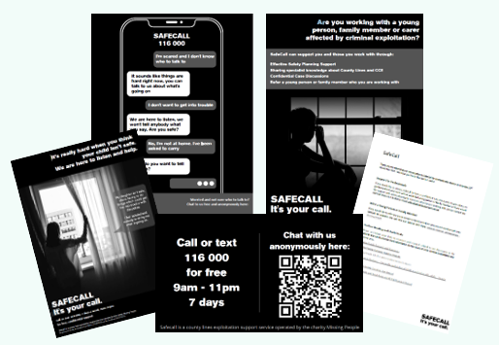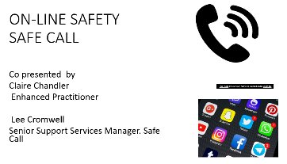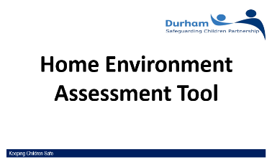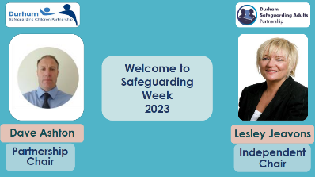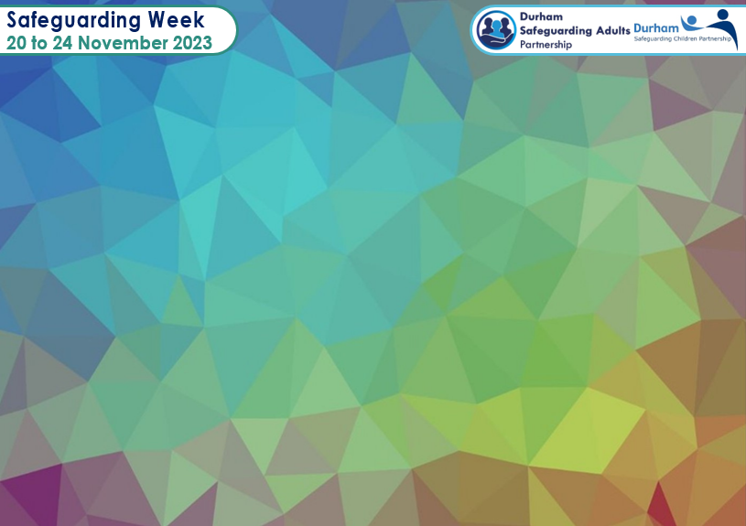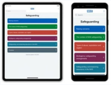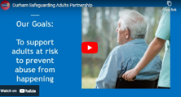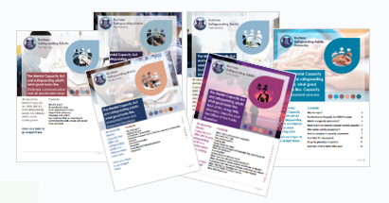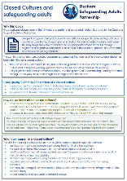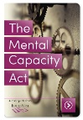

**SafeCall Resources**

* **SafeCall Poster**
* **Business Cards**
* **SafeCall Poster – Professionals**
* **SafeCall Poster YP**
* **SafeCall Durham Handout**

**Online Safety – An Introduction to SafeCall**

Presentation PDF

(double click to open)

**Useful Links**

* **Film –** [**‘Would U leave your front door wide open?’ - YouTube**](https://www.youtube.com/watch?v=E23FLdPrh_s&t=3s)

**Home Environment Assessment (HEAT) Tool**

Presentation PDF

(double click to open)

**Useful links**

* [**Help with your money – Durham County Council**](https://www.durham.gov.uk/helpwithyourmoney)
* [**Stronger Families Grant**](http://www.countydurhamfamilies.info/kb5/durham/fsd/site.page?id=EMxKVkJY5rE)
* [**VCS Alliance – Online Portal**](https://doitonline.durham.gov.uk/service/VCS_Alliance)
* **Start for life fund** [**email address for application**](mailto:sflf@durham.gov.uk)

**Theme What’s My Role in Safeguarding Adults?**

**Monday 20 November**

**Download the NHS England safeguarding app today!**

Safeguarding adults, safeguarding children, mental capacity flowchart, written for everyone **#safeguarding is everybody’s business**

[**https://www.england.nhs.uk/safeguarding/nhs-england-safeguarding-app/**](https://www.england.nhs.uk/safeguarding/nhs-england-safeguarding-app/)

**About us -**

Durham Safeguarding Adults Partnership film

[**http://www.safeguardingdurhamadults.info/article/18022/About-us-**](http://www.safeguardingdurhamadults.info/article/18022/About-us-)

**Key messages from the DSAP Independent Chair**

DSAP presentation PDF (double click to open)

**The Mental Capacity Act and safeguarding adults: What good looks like guides**

* [**Capacity Assessment**](http://www.safeguardingdurhamadults.info/media/41016/MCA-2005-What-Good-Looks-Like-Capacity-Assessment/pdf/MCA2005WhatgoodlookslikeCapacityAssessmentFINAL.pdf?m=638013360595770000)
* [**Next of kin, Attorneys and Deputies**](http://www.safeguardingdurhamadults.info/media/41087/What-good-looks-like-Next-of-Kin-Attorneys/pdf/WhatgoodlookslikeNextofKinAttorneys.pdf?m=638029001511770000)
* [**Capacity, the Act and the Court of Protection**](http://www.safeguardingdurhamadults.info/media/41492/The-Mental-Capacity-Act-and-safeguarding-adults-what-good-looks-like-Best-Interests-Decision-Making-Process/pdf/WhatGoodLooksLikeBestInterestsDecisionMakingProcess.pdf?m=638089635847900000)
* [**Best Interests Decision Making Process**](http://www.safeguardingdurhamadults.info/media/41492/The-Mental-Capacity-Act-and-safeguarding-adults-what-good-looks-like-Best-Interests-Decision-Making-Process/pdf/WhatGoodLooksLikeBestInterestsDecisionMakingProcess.pdf?m=638089635847900000)
* [**Forms and Expected Standards**](http://www.safeguardingdurhamadults.info/media/41723/Mental-Capacity-Act-2005-What-Good-Looks-Like-Assessment-Form-and-Standards/pdf/MCA2005WhatGoodLooksLikeAssessmentFormAndStandards.pdf?m=638126768297670000)
* [**Preferred Communication and all Practicable Support**](http://www.safeguardingdurhamadults.info/media/42235/Mental-Capacity-Act-2005-What-Good-Looks-Like-Preferred-Communication-and-all-Practicable-Steps/pdf/MCA2005WhatGoodLooksLikePreferredCommunicationAndAllPracticableSteps.pdf?m=638200907524870000)

**Transitional Safeguarding**

Key messages in relation to the long-term impact of abuse, importance of language, capacity and consent, and the need for a trauma informed approach. The report focuses on the harms associated with sexual exploitation and criminal exploitation.

[**‘Bridging the Gap, Transitional safeguarding**](https://assets.publishing.service.gov.uk/government/uploads/system/uploads/attachment_data/file/990426/dhsc_transitional_safeguarding_report_bridging_the_gap_web.pdf)

**DSAP Webpage on Disclosure and Barring Service**

* [**Disclosure and Barring Service (DBS) - Durham Safeguarding Adults**](http://www.safeguardingdurhamadults.info/article/18054/Disclosure-and-Barring-Service-DBS-)
* [**DBS checks for adult social care roles**](https://assets.publishing.service.gov.uk/government/uploads/system/uploads/attachment_data/file/871018/Social_care_roles_for_adults_v1.0.pdf)
* [**Barring referrals: Your guide to how and when to make one**](https://assets.publishing.service.gov.uk/government/uploads/system/uploads/attachment_data/file/792793/CCS0119367774-001_Barring_Referrals_Document__Flowchart_A5_Booklet_V3_DG-2.pdf)

If you carry out DBS checks you must have a policy on employing ex-offenders. You must show the policy to any applicant who asks. For a sample policy visit:

[**Sample policy on the recruitment of ex-offenders**](https://www.gov.uk/government/publications/dbs-sample-policy-on-the-recruitment-of-ex-offenders/sample-policy-on-the-recruitment-of-ex-offenders)

**Closed Cultures Briefing**

[**DSAP Closed Cultures Briefing**](http://www.safeguardingdurhamadults.info/media/40845/Closed-Cultures-and-Safeguarding-Adults/pdf/Closed_Cultures_and_safeguarding_adults.pdf?m=637994392302900000)

**CQC Resources**

* [**Durham Police Article on Whorlton Hall Convictions**](https://www.durham.police.uk/News/News-Articles/2023/April/Four-convicted-of-ill-treatment-in-Whorlton-Hall-case.aspx)
* [**Safeguarding Adults Review into Whorlton Hall**](http://www.safeguardingdurhamadults.info/media/42270/Safeguarding-Adults-Review-Whorlton-Hall-May-2023/pdf/WhorltonHallReport-May2023.pdf?m=638205410398630000)
* [**How CQC identifies and responds to closed cultures - Care Quality Commission**](https://www.cqc.org.uk/guidance-providers/all-services/how-cqc-identifies-responds-closed-cultures)
* [**Closed Cultures – Summer 2022 update - Care Quality Commission (cqc.org.uk)**](https://www.cqc.org.uk/publications/themes-care/our-work-closed-cultures/closed-cultures-summer-2022-update)
* [**The Human Rights Act | Equality and Human Rights Commission (equalityhumanrights.com)**](https://www.equalityhumanrights.com/en/human-rights/human-rights-act)
* [**Services for autistic people and people with a learning disability - Care Quality Commission (cqc.org.uk)**](https://www.cqc.org.uk/guidance-providers/autistic-people-learning-disability/right-support-right-care-right-culture)
* [**https://restraintreductionnetwork.org/**](https://restraintreductionnetwork.org/)
* [**https://www.bild.org.uk/vision-values/**](https://www.bild.org.uk/vision-values/)
* [**Skills for Care.org.uk-Developing your workforce; Behaviours which challenge, a positive and proactive workforce**](https://www.skillsforcare.org.uk/resources/documents/Developing-your-workforce/Care-topics/Behaviours-which-challenge/A-positive-and-proactive-workforce.pdf)
* [**CQC Quality of Life Tool**](https://www.cqc.org.uk/guidance-providers/autistic-people-learning-disability/quality-life-tool)

**Mental Capacity Act elearning**

This is CPD accredited training from Social Care Institute for Excellence (SCIE)

[**Mental Capacity Act (MCA): e-Learning course | SCIE**](https://www.scie.org.uk/e-learning/mca?utm_campaign=13492434_SCIELine_26September2022&utm_medium=email&utm_source=SOCIAL%20CARE%20INSTITUTE%20FOR%20EXCELLENCE%20&utm_sfid=003G000002R5GhJIAV&utm_role=Manager&dm_i=4O5,816TU,M1VI5M,WV3U7,1)

**Mental Capacity Act app**

[**The Mental Capacity Act - Apps on Google Play**](https://play.google.com/store/apps/details?id=com.mcaapp&gl=US)

**Creating Safer Organisational Cultures**

presentation PDF (double click to open).

**Bridging the Gap: Safeguarding and Transitions**

DSAP presentation PDF (double click to open)

**Making Recruitment Safer**

presentation PDF (double click to open)

**Working with Families who have English as an Additional Language**

presentation PDF (double

click to open)

**Theme Let’s Start Talking: Taking the Lead on Safeguarding in your Organisation**

**Tuesday 21 November**

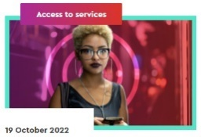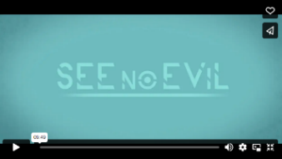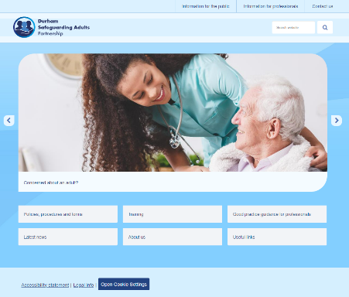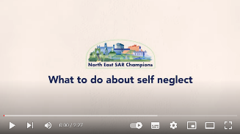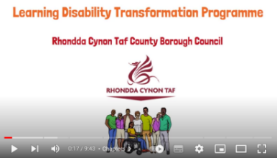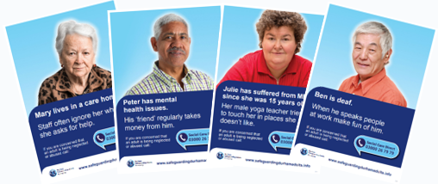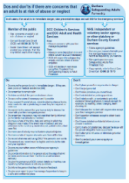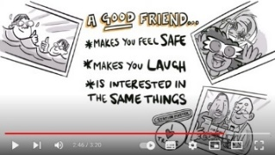

**Durham Safeguarding Adults Partnership Website**

[**http://www.safeguardingdurhamadults.info/**](http://www.safeguardingdurhamadults.info/)

**What to do about self-neglect**

Short film launched in Safeguarding Adults Week 2022

[**What to do about self neglect - YouTube**](https://www.youtube.com/watch?v=nKLzuQBvpFY)

**My Day, My Way!**

Great resource for SG Week

[**Myday Myway - YouTube**](https://www.youtube.com/watch?v=T75_c3RNi1A)

**Posters Available**

Posters for care settings, staff noticeboards, and community venues, and the Dos and Don’ts leaflet for staff and volunteers to use

[**safeguardingdurhamadults/Leaflets-and-posters**](http://www.safeguardingdurhamadults.info/article/18052/Leaflets-and-posters)



**Resources also available through the Ann Craft Trust**

[**Safeguarding Adults Week 2023 Resources**](https://www.anncrafttrust.org/safeguarding-adults-week-2023-resources/)

**Safeguarding Adults in Care Homes NICE Guidance**

Useful for all employers and managers

* [**Creating a safeguarding culture**](https://www.nice.org.uk/Media/Default/About/NICE-Communities/Social-care/quick-guides/Creating-a-safeguarding-culture.pdf)
* [**Recommendations | Safeguarding adults in care homes | Guidance | NICE**](https://www.nice.org.uk/guidance/ng189/chapter/Recommendations)

**See No Evil**

Direct link to See No Evil film plus link to Blue Apple to join and access other resources

[**See No Evil — Blue Apple (blueappletheatre.com)**](https://blueappletheatre.com/seenoevil#SNEEducate)

**Young people’s digital lives**

Digital Youth Index report on the digital lives and wellbeing of children and young adults aged 8 to 25.

Six percent found online life has a negative impact on their friendships, and 29% had experienced hate speech online.

[**Young people’s digital lives**](https://digitalyouthindex.uk/regional-comparisons/)

**Tricky Friends**

Three-minute film to support and empower adults to speak to someone they trust when ‘something’s not right’, to share with clients. The film is on our webpage

[**http://www.safeguardingdurhamadults.info/article/18027/What-is-abuse-**](http://www.safeguardingdurhamadults.info/article/18027/What-is-abuse-)

**Unaccompanied Asylum Seeking Children**

presentation PDF (double click to open).

**Harm Outside the Home**

presentation PDF (double click to open).

**Theme Who Cares for the Carers? Secondary and Vicarious Trauma**

**Wednesday 22 November**

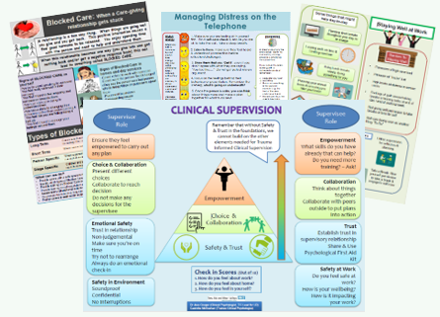****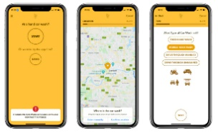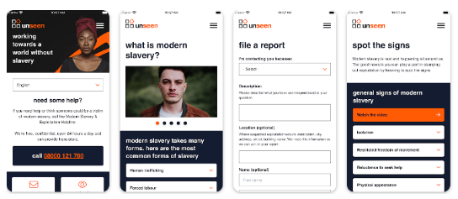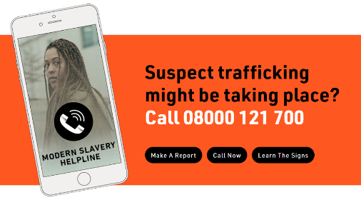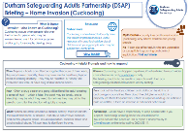

**TEWV Trauma Informed Care Posters**

Downloadable posters for printing and displaying in staff areas

**Durham Community Action Safeguarding Week links**

[**Durham Community Action.org.uk/safeguarding**](https://www.durhamcommunityaction.org.uk/safeguarding.html)

**Videos**

[**Durham Community Action - Safeguarding Week 2023**](https://www.durhamcommunityaction.org.uk/safeguarding-week-2023)

**Motivating Clients**

Watch this space for the full course.

* [**DSAP Training Webpage**](http://www.safeguardingdurhamadults.info/article/18072/Training)

**Home Invasion/ Cuckooing Briefing**

Information and resources about Home Invasion, also known as Cuckooing

[**DSAP Home-Invasion-Cuckooing-Briefing.pdf**](http://www.safeguardingdurhamadults.info/media/36435/Durham-Safeguarding-Adults-Partnership-Home-Invasion-Cuckooing-Briefing/pdf/CuckooingBriefing.pdf?m=638307368471730000)

**Unseen app**

To help recognise and report all forms of Modern Slavery; access via Windows, the App store or Google Play

[**Download The App - Unseen (unseenuk.org)**](https://www.unseenuk.org/about-modern-slavery/download-the-app/)

**Safe Car Wash app and Farm Work Welfare app**

Clewer Initiative apps to help report concerns about modern slavery; access via your app store

[**The Clewer Initiative | Safe Car Wash App**](https://theclewerinitiative.org/campaigns/safe-car-wash)

**A21 Campaign**

Information resources and to report modern slavery

[**United Kingdom | A21**](https://www.a21.org/content/united-kingdom/gr507k)

**Safeguarding in voluntary and community organisations**

PDF (double click to open).

**Modern Slavery ‘Must Knows’**

PDF (double click to open).

**Having Motivational Conversations with Clients**

PDF (double click to open).

**Trauma Informed Approaches**

PDF (double

click to open).

**Theme Adopting a Trauma Informed Approach to Safeguarding Adults**

**Thursday 23 November**

****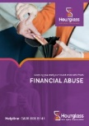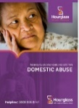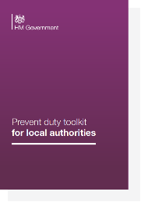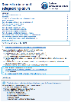

**Staff and supervision**

* [**Landing Page - Practice Supervisor Development Programme Repository (rip.org.uk)**](https://practice-supervisors.rip.org.uk/)
* [**We need to talk about overwhelm | Research in Practice**](https://www.researchinpractice.org.uk/children/news-views/2022/july/we-need-to-talk-about-overwhelm-setting-boundaries-in-a-complex-work-culture/)

**Support and advice for carers**

* **Durham County Carers Support** [**https://dccarers.org/**](https://dccarers.org/)
* **The Bridge Young Carers Service** [**http://www.countydurhamfamilies.info/**](http://www.countydurhamfamilies.info/kb5/durham/fsd/organisation.page?id=MC512uPyJxw)
* **Significant Care Tool:** free tool to help carers spot deterioration. Download an [**easy print copy**](https://s31836.pcdn.co/wp-content/uploads/Significant-Care-Tool-landscape-print-version-21.04.20-with-all-links-1.pdf) and/or a [**booklet for professional printing**](https://s31836.pcdn.co/wp-content/uploads/Significant-Care-Tool-V.21.04.20-high-resolution.pdf)**.** Significant Care – [**a short video explaining the benefits and how to use the tool.**](https://www.youtube.com/watch?v=WlIkzWpIJYA&feature=youtu.be)
* **Care Home Visiting Restrictions in England, April-September 2022**

Relatives and Residents Association Summary Report [**survey**](https://www.rightsforresidents.co.uk/wp-content/uploads/2022/10/RfR-RRA-Summary-Report-Visiting-Restrictions-Sep-Apr-2022.pdf)

* **Carers and safeguarding** [**A briefing for people who work with carers | Local Government Association**](https://www.local.gov.uk/parliament/briefings-and-responses/carers-and-safeguarding-briefing-people-who-work-carers#carers-rights-under-the-care-act-2014-)

**Hourglass Research and Resources**

Resources to download

[**https://wearehourglass.org/resources**](https://wearehourglass.org/resources)

**Durham Mental Wellbeing Alliance**

The Durham Mental Wellbeing Alliance co-produced a booklet called **The Little Book of Anxiety**

* [**The Little Book of Anxiety**](https://www.durhammentalwellbeingalliance.org/wp-content/uploads/2023/05/The-Little-Book-of-Anxiety.pdf)

**Prevent Duty Guidance and Supporting Toolkit**

The Prevent duty guidance has been updated and will come into force on 31 December, subject to Parliamentary approval. The updated Prevent duty toolkit has practical information and suggestions to protect people from radicalisation.

* [**Prevent duty guidance: England and Wales (2023) - GOV.UK (www.gov.uk)**](https://www.gov.uk/government/publications/prevent-duty-guidance)
* [**Prevent duty toolkit**](https://response.smartwebportal.co.uk/homeofficeR4/cresponse.asp?load=NBBNAYMRMa8fC%3c?KE7AA|QNE%5ePHGUXL7AA|scSPA7AA|NFLTOK\7AA|REJEP:%3cHKALLhPWNJZ%5eOUJDbEMoTY@tNVNdepLISSGnHQQ%5dipv$!jjgeqEL%5e2AA|kwfln?EP)

**Co-Production**

SCIE (Social Care Institute for Excellence) has released two films on co-production

* [**What it is and how to do it**](https://www.scie.org.uk/co-production/what-how)
* [**Practice examples**](https://www.scie.org.uk/co-production/examples/animated-film-coproduction-examples)

SCIE co-production resources visit [**https://www.scie.org.uk/co-production/**](https://www.scie.org.uk/co-production/)

**LGA – Carers and Safeguarding briefing**

[**Carers and safeguarding: a briefing for people who work with carers | Local Government Association**](https://www.local.gov.uk/parliament/briefings-and-responses/carers-and-safeguarding-briefing-people-who-work-carers)

**DSAP domestic abuse and safeguarding adults briefing**

Updated in 2022 with a new section on dementia and domestic abuse

[**Domestic Abuse and Safeguarding Adults Briefing (safeguardingdurhamadults.info)**](http://www.safeguardingdurhamadults.info/media/32883/SAB-Briefing-Domestic-abuse-and-safeguarding-adults/pdf/SAB_Briefing_Domestic_Abuse_and_Safeguarding_Adults.pdf?m=637496802091330000)

**Concern about radicalisation in County Durham- Prevent Flowchart and e-learning**

[**Prevent Strategy: Countering Terrorism, Radicalisation and Violent Extremism (countydurhampartnership.co.uk)**](https://countydurhampartnership.co.uk/safe-durham-partnership/vision-and-priorities/prevent-strategy-countering-terrorism-radicalisation-and-violent-extremism/)

**Just Words… The Importance of Language**

Presentation PDF (double click to open).

**Safeguarding Adults for People who are Caring for an Adult**

Presentation PDF (double click to open).

**Prevent Awareness**

Presentation PDF (double click to open).

**Theme Listen, Learn, Lead: Co-Production with Experts by Experience**

**Friday 24 November**